**SUPER (VS) PROPERTY**

**What works for retirement income?**

There is no debate that Australians love investing in property. The value of Australian residential real estate at the end of August 2024 was an estimated $10.95 trillion.

Some love it so much that they believe property is a better option for providing a retirement income. They see a bricks and mortar investment as a more tangible and solid approach than say, superannuation, preferring to take their super as a lump sum on retirement to buy property. They may also choose to invest a windfall, such as an inheritance, or the proceeds from downsizing the family home, in property instead of their super.

So, given that a retired couple above age 65 needs an estimated yearly income $73,337 to lead a comfortable lifestyle, could a property investment do the job?ii

While it's true that a sizeable property portfolio could deliver rental income to equal a super pension, it might mean. missing out on some useful benefits.

After all, super is a retirement savings structure with significant tax advantages. It also has the flexibility to provide investments in a range of different asset classes, including property.

Meanwhile, super fund performance has, generally speaking, outstripped house price movements over the past decade. Super funds (invested in an all-growth category) returned an annual average of 9.1 per cent during that time while average house prices in Australian capital cities grew 6.5 per cent per year over the same period., iv

Not that past performance can give you any guarantees about what will happen in the future. Indeed, the average numbers smooth out the years of high returns and the years of negative returns. More important considerations in making an informed decision are your financial goals, your investment timeframe and how much risk you're comfortable with.

**Liquidity**

One of the most significant differences between super and property investments is liquidity, or how quickly you can convert your investment to cash.

With super, assuming you're eligible, funds can be accessed relatively easily and quickly. On the other hand, if your wealth is tied up in property it may take some time to sell or it may sell at a lower price.

Nonetheless, market cycles affect both property and super investments. They can be affected by volatile conditions and deliver negative returns just at the time you need access to a lump sum.

**Long-term investing**

Superannuation is designed for long-term growth, often spanning decades as you accumulate wealth over your working life. The magic of compounding interest can lead to substantial growth over time, depending on your investment options and the state of the market.

Property investments, on the other hand, can be invested for short, medium, and long-term growth depending on the suburb, the street, and the type of house you invest in.

Of course, there are additional costs in buying a property (such as stamp duty) plus costs in selling (including capital gains tax). If there's a mortgage over the property, you'll need to factor in the additional costs of repayments and interest (bearing in mind that interest on investment properties is tax deductible).

**The performance of superannuation and property**

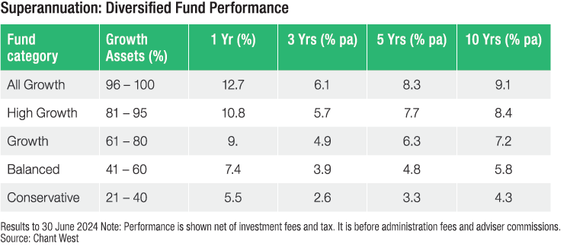

**

**Risk appetite**

Investors' attitudes towards risk also play a role in choosing between super and property.

Superannuation funds can be diversified across various asset classes, which helps to reduce risk. But property investments expose investors to a single market meaning that while there might be a big benefit from an upswing, any downturn may be a blow to a portfolio.

**Making an informed choice**

Ultimately, any decision between superannuation and property should align with individual financial goals, risk tolerance, and investment strategies. And, of course, it doesn't need to be one or the other - many choose to rely on their super while also holding investment property so it's best to understand how super and property can complement each other in a well-rounded retirement plan.

We'd be happy to help you analyse your retirement income strategy to develop a plan that works for you.

*i https://www.corelogic.com.au/news-research/news/2024/almost-30-of-suburbs-have-seen-values-fall-over-the-quarter*

*ii https://www.superannuation.asn.au/wp-content/uploads/2024/08/ASFA_Retirement_Standard_Budgets_June-24_quarter.pdf*

*iii https://www.chantwest.com.au/media/sinh0t1t/chant-west-media-release-17-july-2024-final.pdf*

*iv https://sqmresearch.com.au/asking-property-prices.iphp?avg=1&t=1*

**ASHFORDS WEALTH ADVISORS**

Level 3/148 Logis Blvd

Dandenong South VIC 3175

**P:** (03) 9551 2822 **E:** info@ashfords.com.au **W:** https://www.ashfords.com.au **Facebook:** AshfordsAccountants

Liability Limited by a scheme approved under Professional Standards Legislation. ACN 607 345 522© Ashfords Accountants & Advisory 2025  
AFSL (Australian Financial Services licence) 226184

Ashfords Wealth Advisors Pty Ltd hold an Australian Financial Services Licence 226184   
This advice may not be suitable to you because it contains general advice that has not been tailored to your personal circumstances. Please seek personal financial advice prior to acting on this information. Investment Performance: Past performance is not a reliable guide to future returns as future returns may differ from and be more or less volatile than past returns.

